**“SMART PHONE DIRECTORY SYSTEM”**

Project submitted to the

SRM University – AP, Andhra Pradesh

for the partial fulfillment of the requirements to award the degree of

**Bachelor of Technology**

In

**Computer Science and Engineering**

**School of Engineering and Sciences**

Submitted by

Divya sri. N – AP21110010067

Bhuvitha.T – AP21110010094

Kumar varma.T – AP21110010106

Varshith.J – AP21110010107

Under the Guidance of

**(**Kavitha Rani Karnena**)**

**SRM University–AP**

**Neerukonda, Mangalagiri, Guntur**

**Andhra Pradesh – 522 240**

**[12, 2022]**

# Certificate

Date: 22-Dec-22

This is to certify that the work present in this Project entitled “**PROJECT TITLE**” has been carried out by **[Name of the Candidate]** under my/our supervision. The work is genuine, original, and suitable for submission to the SRM University – AP for the award of Bachelor of Technology/Master of Technology in **School of Engineering and Sciences**.

**Supervisor**

(Signature)

Prof. / Dr. [Name]

Designation,

Affiliation.

**Co-supervisor**

(Signature)

Prof. / Dr. [Name]

Designation,

Affiliation.

# Table of Contents

Certificate 1

Table of Contents 2

Abstract 3

1. Introduction 4

2. Methodology 5

3. Discussion 13

4. Concluding Remarks 16

References 17

# Abstract

Through this project we will be implementing a smartphone directory that collects contact data from the user until the user prompts the program to. Contact data refers to the contact’s name, phone number, date-of-birth, a category that contact belongs to (Friends, Family, Work, Other), e-mail address. The user may enter as much data as he can in the mentioned data labels. If some labels remain void of data, store it as None. A name & the number is mandatory to create contact. Implementation of the following operations will be done on the directory:

* Insert
* Delete
* Search
* Display.

prompts the .

# Introduction

This project “SMART PHONE DIRECTORY SYSTEM” have been developed using python. Smart phone directory system (Contact books) is a useful and widely used kind of application. They’re everywhere. You probably have a contact book on your phone and on your computer. With a contact book, you can store and manage contact information for your family members, friends, coworkers, and so on.

The main functions available in this project are

* **initial_phone_book()**: The first function to run, it initializes the phonebook.
* **menu()**: It displays the choices available to the
* user and returns the choice entered.
* **add_contact()**: It adds a new contact
* to the Contacts directory.
* **remove_existing()**: It removes an existing
* contact from the Contacts directory.
* **deleteall():** It deletes all the contacts
* from the Contacts directory.
* **displayall():** It displays all the contacts
* from the Contacts directory.
* **Search_existing()**: It will search and display
* an existing contact in the Contacts directory.

thanks() :

# Methodology

import sys

def initial_phone_book():

vertical, horizontal = int(input("Please enter initial number of contacts: ")),5

phonebook = []

print(phonebook)

for i in range(vertical):

print("\nEnter contact %d details in the following order :" % (i+1))

print("NOTE:( * ) indicates mandatory fields")

print("....................................................................")

temp = []

for j in range(horizontal):

if j == 0:

temp.append(str(input("Enter the name * : ")))

if temp[j] == '' or temp[j] == ' ':

sys.exit(

"Name is a mandatory field. Process exiting due to blank field...")

if j == 1:

temp.append(int(input("Enter number * : ")))

if j == 2:

temp.append(str(input("Enter mail address : ")))

if temp[j] == '' or temp[j] == ' ':

temp[j] = None

if j == 3:

temp.append(str(input("Enter date of birth (dd/mm/yy) : ")))

if temp[j] == '' or temp[j] == ' ':

temp[j] = None

if j == 4:

temp.append(

str(input("Enter category (Family/Friends/Work/Others) : ")))

if temp[j] == "" or temp[j] == ' ':

temp[j] = None

phonebook.append(temp)

print(phonebook)

return phonebook

def menu():

print("************************")

print("\t\t\tSMARTPHONE DIRECTORY", flush=False)

print("************************")

print("\tYou can now perform the following operations on this phonebook\n")

print("1. Add a new contact")

print("2. Remove existing contact")

print("3. Delete all contacts")

print("4. Search for a contact")

print("5. Display all contacts")

print("6. Exit phonebook")

optional = int(input("Please enter your choice: "))

return optional

def add_contact(phbk):

array = []

for i in range(len(phbk[0])):

if i == 0:

array.append(str(input("Enter the name : ")))

if i == 1:

array.append(int(input("Enter number : ")))

if i == 2:

array.append(str(input("Enter mail address : ")))

if i == 3:

array.append(str(input("Enter date of birth (dd/mm/yy) : ")))

if i == 4:

array.append(

str(input("Enter category (Family/Friends/Work/Others) : ")))

phbk.append(array)

return phbk

def remove_existing(phbk):

query = str(input("Enter the name of the contact you wish to remove : "))

temp = 0

for i in range(len(phbk)):

if query == phbk[i][0]:

temp += 1

print(phbk.pop(i))

print(" This query has now been removed")

return phbk

if temp == 0:

print("Sorry, you have entered an invalid query.\

Please recheck and try again later.")

return phbk

def deleteall(phbk):

return phbk.clear()

def search_existing(phbk):

optional = int(input("Enter search criteria\n\n\

1. Name\n2. Number\n3. Email-id\n4. DOB\n5. Category(Family/Friends/Work/Others)\

\nPlease enter: "))

temp = []

check = -1

if optional == 1:

query = str(

input("Please enter the name of the contact you wish to search: "))

for i in range(len(phbk)):

if query == phbk[i][0]:

check = i

temp.append(phbk[i])

elif optional == 2:

query = int(

input("Please enter the number of the contact you wish to search: "))

for i in range(len(phbk)):

if query == phbk[i][1]:

check = i

temp.append(phbk[i])

elif optional == 3:

query = str(input("Please enter the mail ID\

of the contact you wish to search: "))

for i in range(len(phbk)):

if query == phbk[i][2]:

check = i

temp.append(phbk[i])

elif optional == 4:

query = str(input("Please enter the DOB (in dd/mm/yyyy format ONLY)\

of the contact you wish to search: "))

for i in range(len(phbk)):

if query == phbk[i][3]:

check = i

temp.append(phbk[i])

elif optional == 5:

query = str(

input("Please enter the category of the contact you wish to search: "))

for i in range(len(phbk)):

if query == phbk[i][4]:

check = i

temp.append(phbk[i])

else:

print("Invalid search criteria")

return -1

if check == -1:

return -1

else:

displayall(temp)

return check

def displayall(phbk):

if not phbk:

print("Directory is empty: []")

else:

for i in range(len(phbk)):

print(phbk[i])

def thanks():

print("************************")

print("Thanks for using our Smartphone directory system.")

print("Please visit again!")

print("************************")

sys.exit("Goodbye, have a good day!")

print("....................................................................")

print("Hello dear user, welcome to our smartphone directory system")

print("You may now proceed to explore this directory")

print("....................................................................")

ch = 1

phbk = initial_phone_book()

while ch in (1, 2, 3, 4, 5):

ch = menu()

if ch == 1:

phbk = add_contact(phbk)

elif ch == 2:

phbk = remove_existing(phbk)

elif ch == 3:

phbk = deleteall(phbk)

elif ch == 4:

d = search_existing(phbk)

if d == -1:

print("The contact does not exist. Please try again")

elif ch == 5:

displayall(phbk)

else:

thanks()

# Discussion

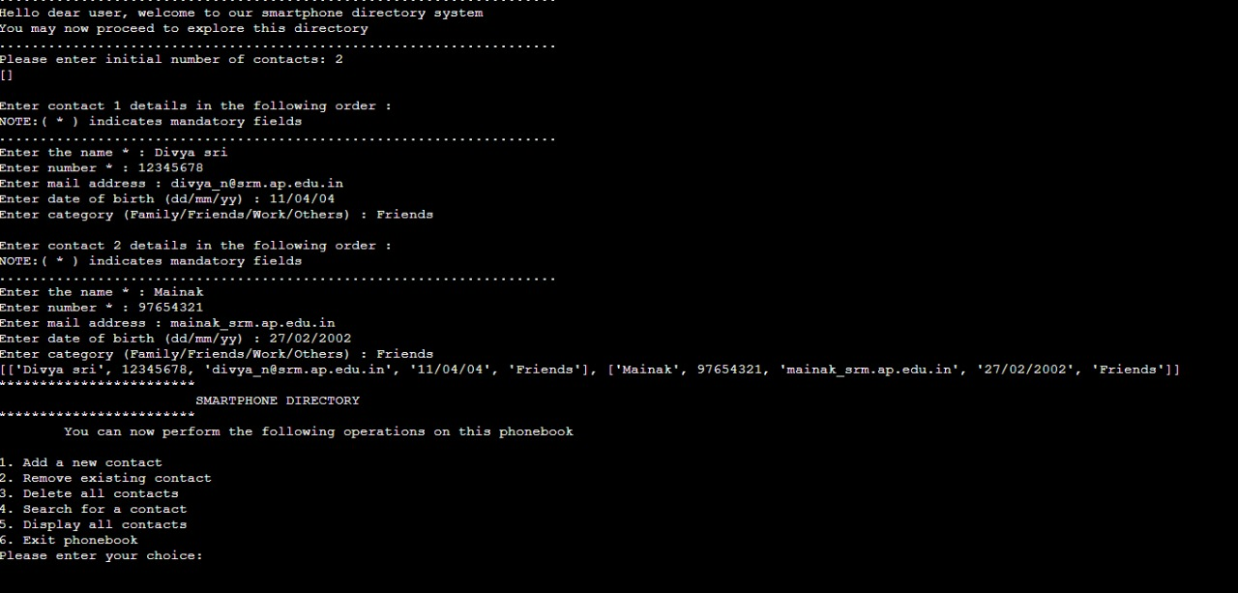

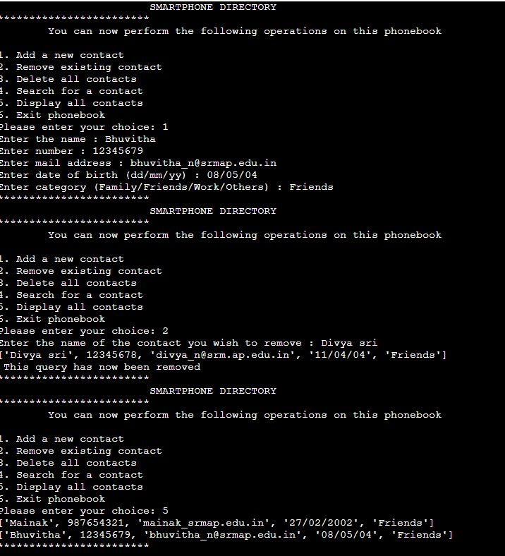

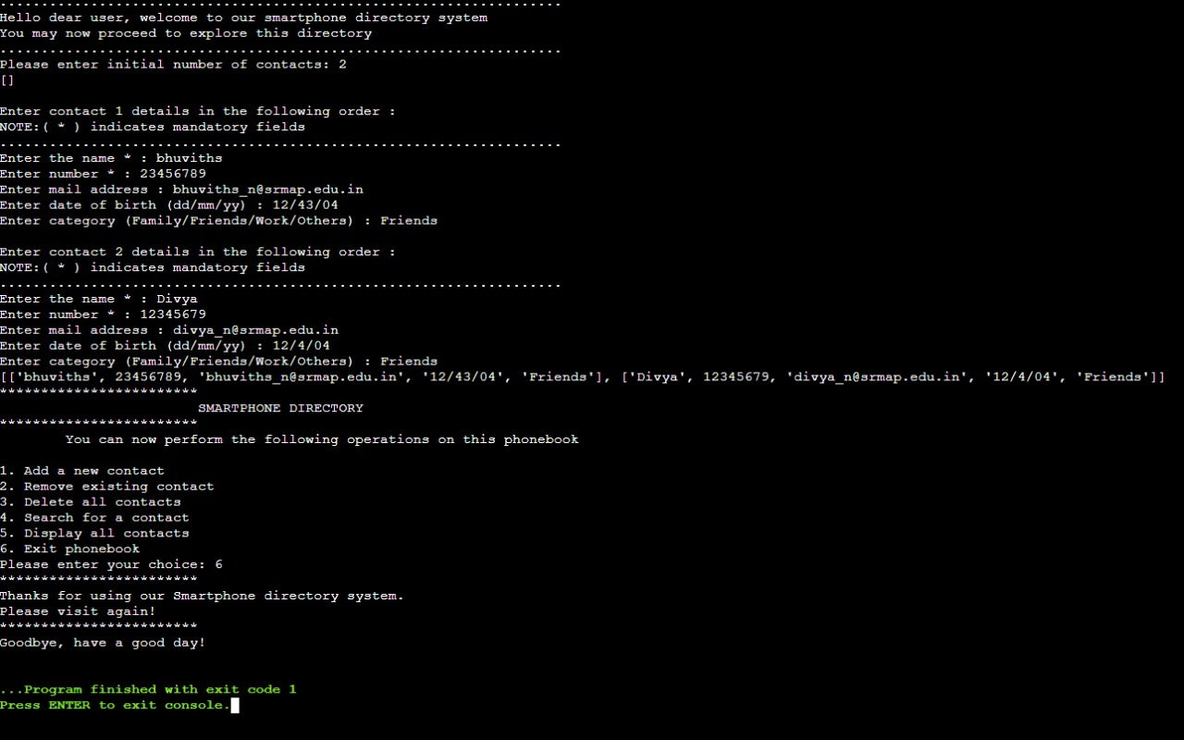

# Concluding Remarks

We have successfully written a python program for a smart phone directory system.

The we learnt in this project are

* Decision making
* Functions
* Lists

# References

1.

Python Programming: An Introduction to Computer Science - John M Zelle

2.

Learning Python, 5th Edition - Mark Lutz